- Create user with name Techie and provide sudo access to user.
.
- Navigate to the home directory
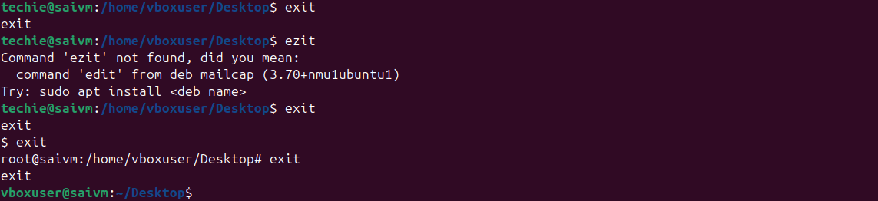

- Create a new directory

- List the contents of a directory

- Change the current directory
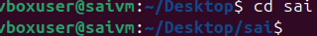

- Create a new empty file
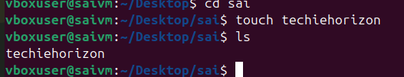

- View the contents on a file
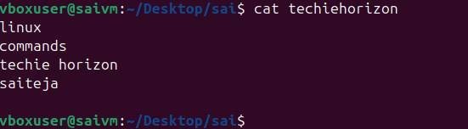

- Copy a file to another location
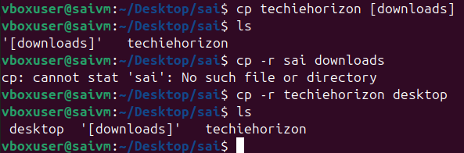

- Move a file to another location
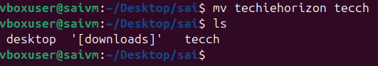

- Rename a file
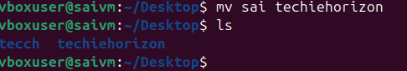

- Delete a file
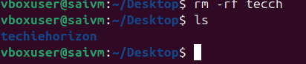

- Grant permission on a file or directory
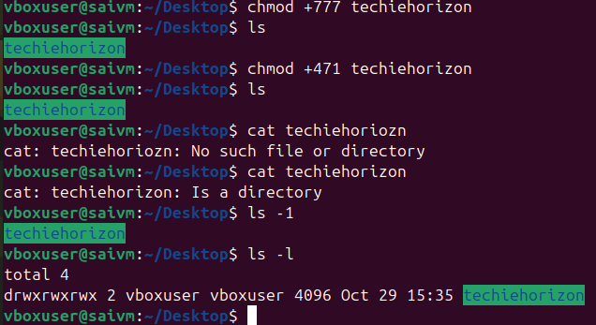

- Revoke of permission
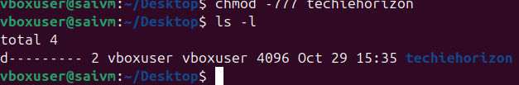

- Change of permission
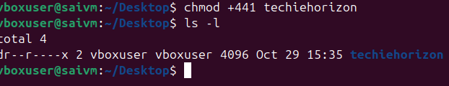

- View the current date and time
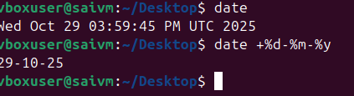

- Check the system uptime
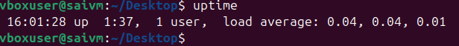

- View the running processes
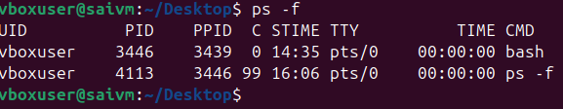

- Kill a running process
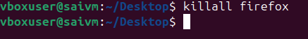

- Install a package using yum or apt
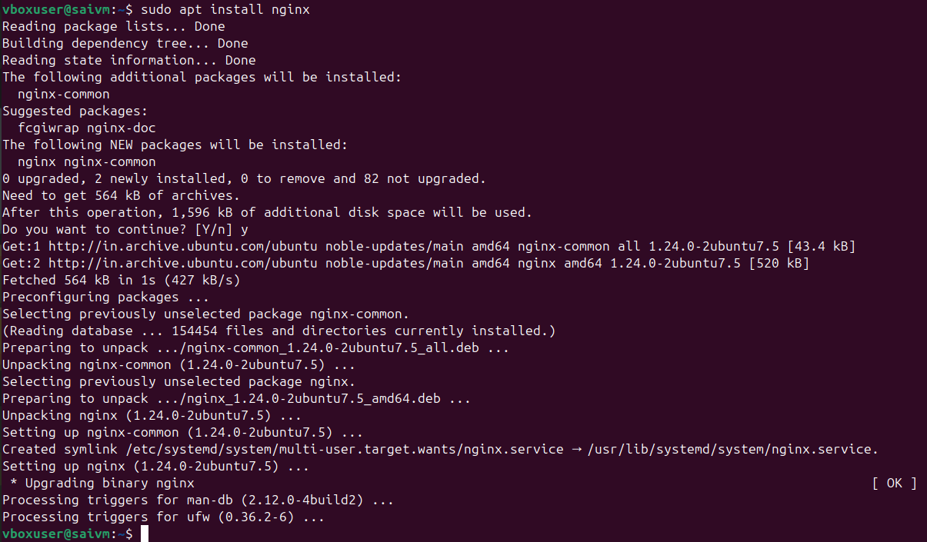

- Update the system packages
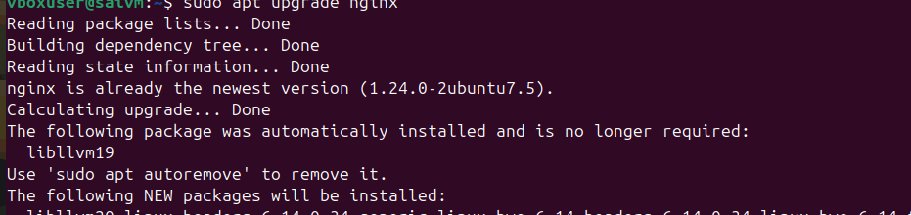
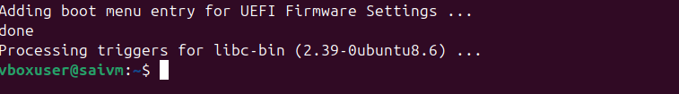

- Create a symbolic link
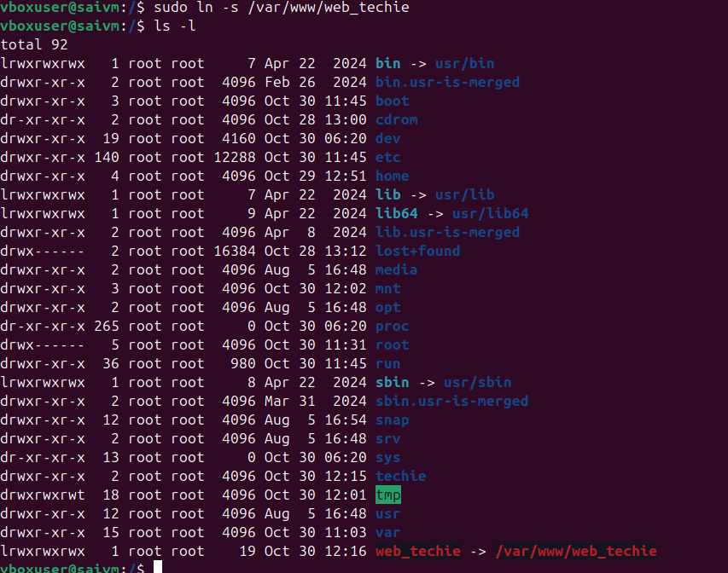

- Search for files using the find command
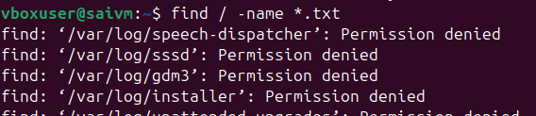

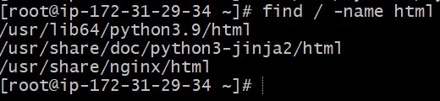

- Compress files using tar
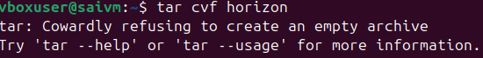
- Decompress using tar

- Monitor system resources with top or htop
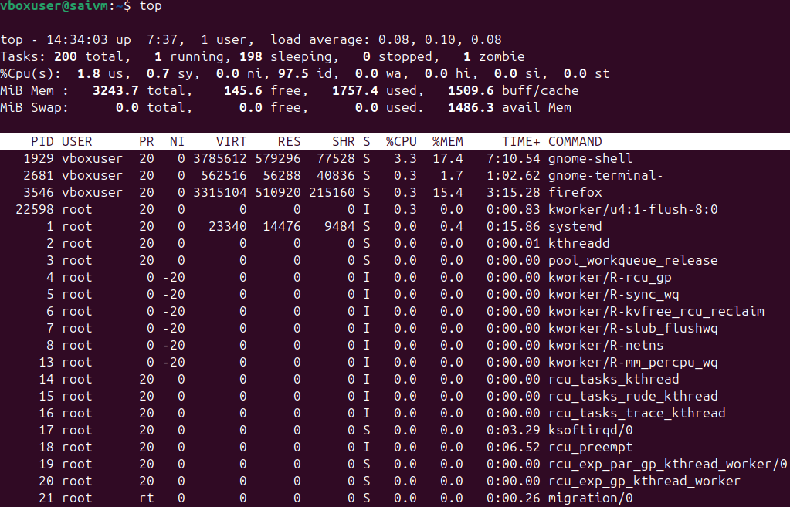

- Create and manage user groups
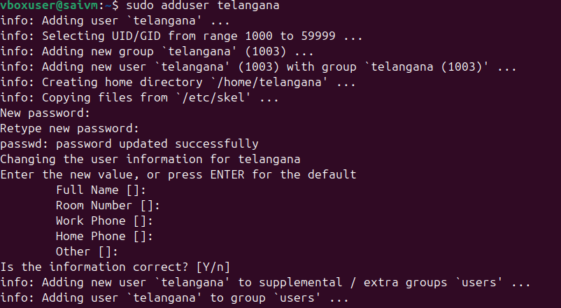
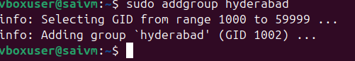

- Set up SSH password less authentication
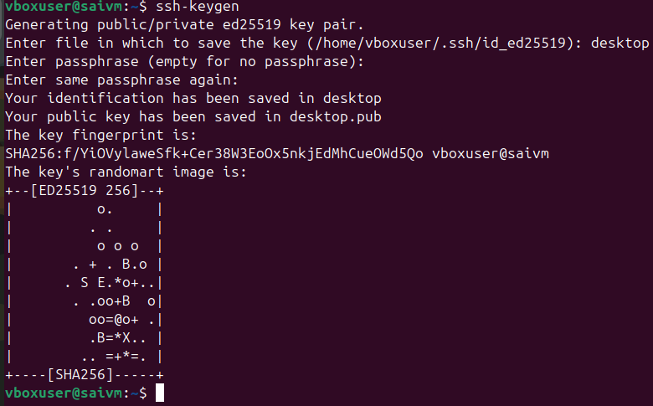

- Monitor log files using tail or grep
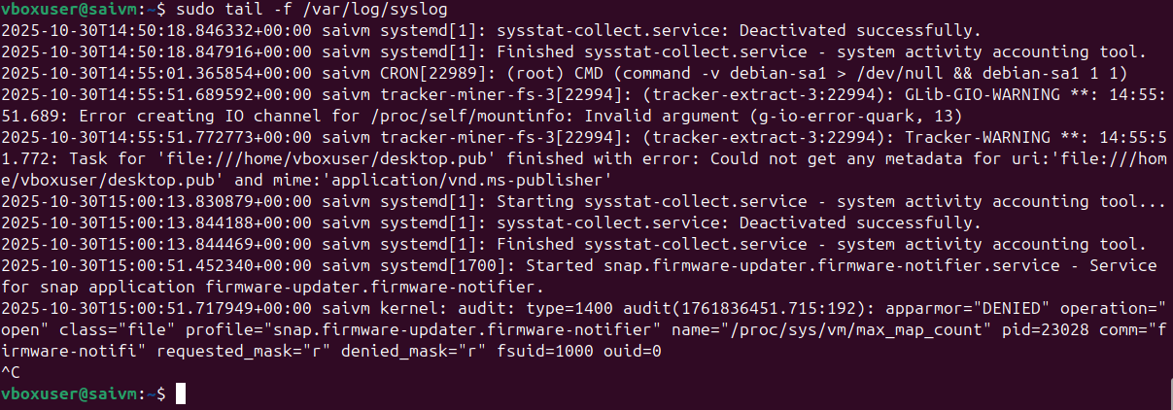

- Set up a web server (e.g., Apache or Nginx)
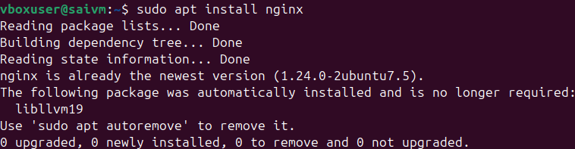

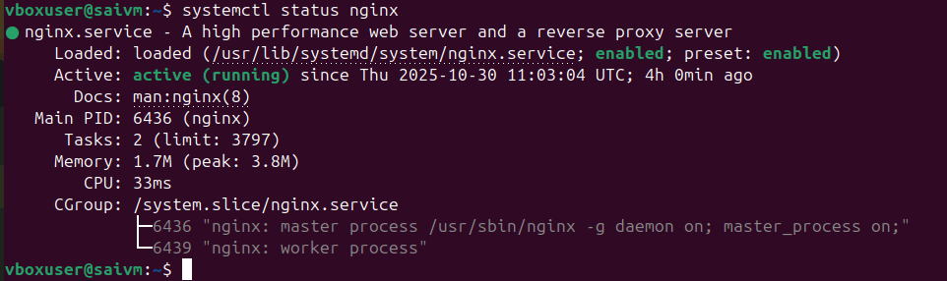
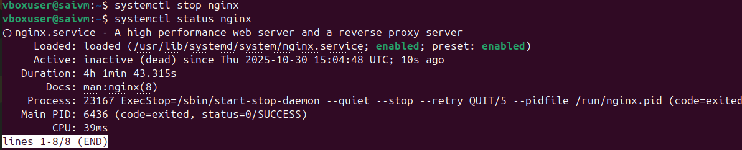
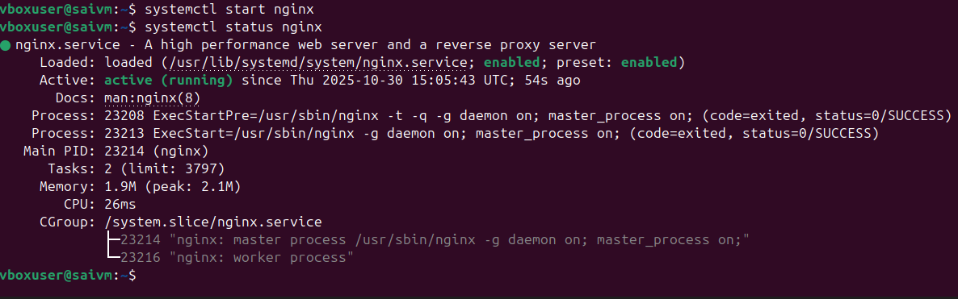

- Configure and secure a MySQL Database
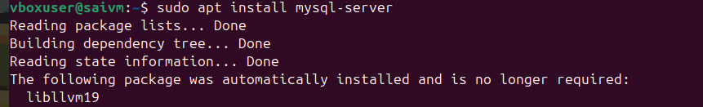
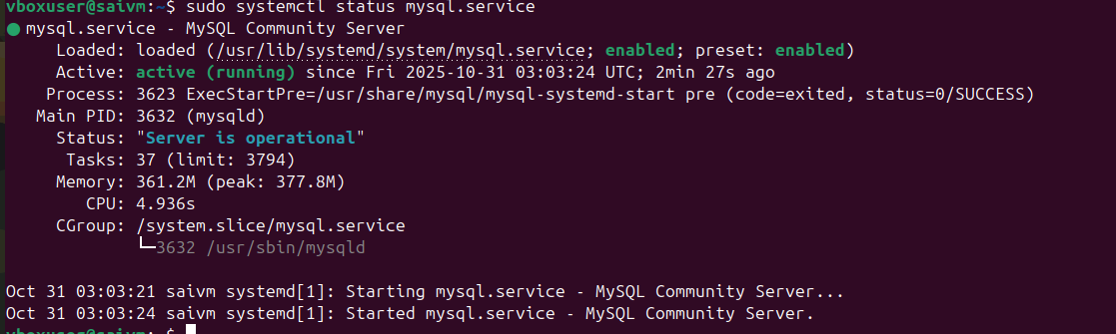
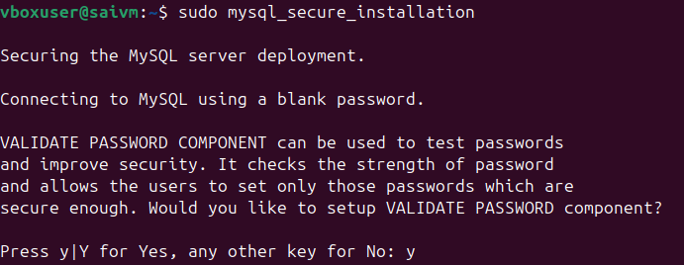

- Installing java
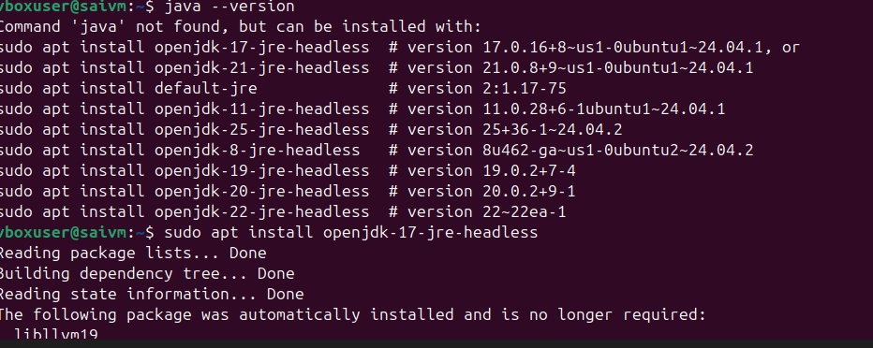

- Set up a Application Server (e.g.,Apache Tomcat)
Step 1 download link from apache tomcat download
And use Wget command or curl command to run
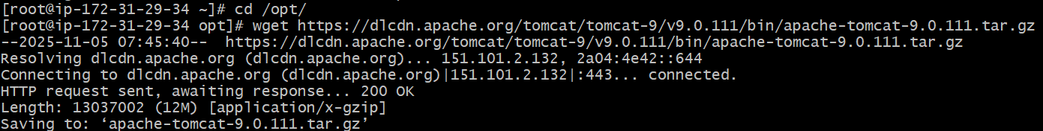

Then list the files using ls and see whether tar.gz file located or not
And use command tar xvf to xtract verbose file
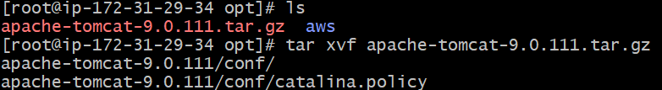
Then change to directory to apache folder
Then list the files
And change to bin
Execute the command ./startup.sh
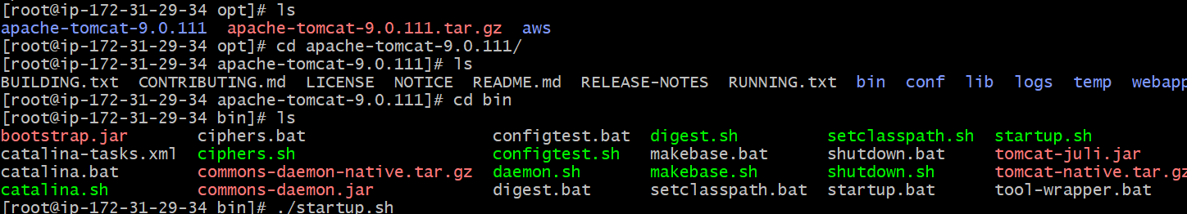
Then check the port using command
Netstat -na | grep 8080
Or ss -tuln
Check in website using ip:8080
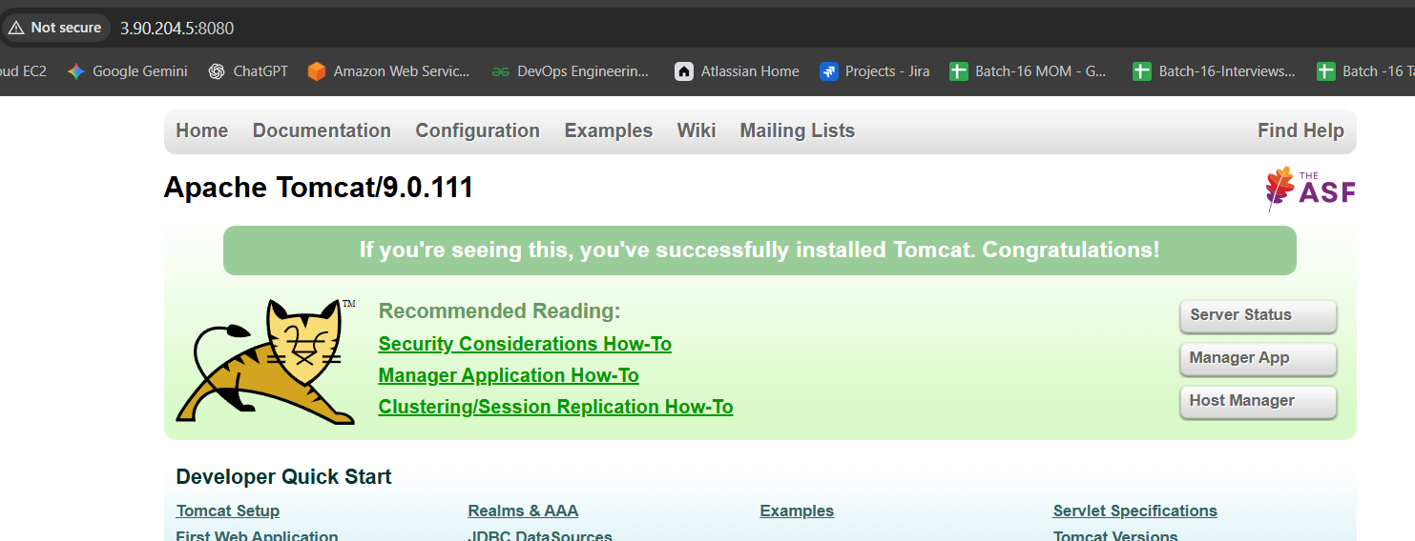

- Perform string manipulation

- Count the occurrences of a specific pattern in a file
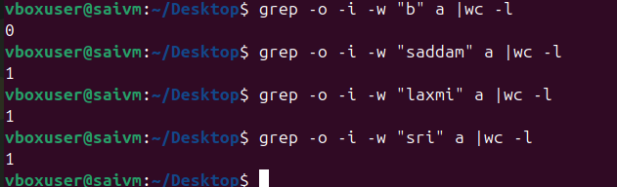

- Print specific columns from a delimited file
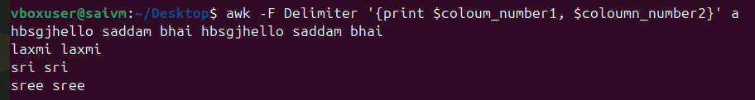

- Filter and print lines based on a specific pattern or condition
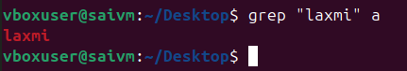

- Calculate and print the average, sum, or other statistics of a column

- Sort lines based on a specific field or column
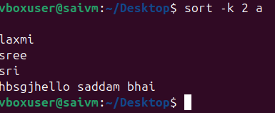

- Merge multiple files based on a common field or column

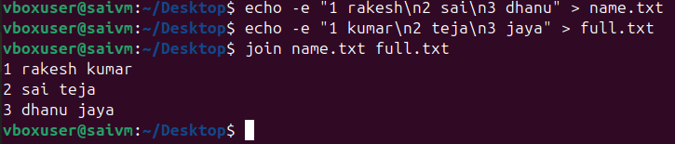

- Substitute text in a file using search and replace.

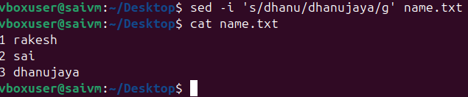

- Delete specific lines based on a pattern or line number
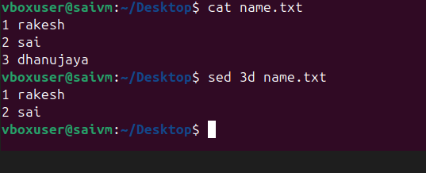
- Append or insert text before or after a specific pattern or line
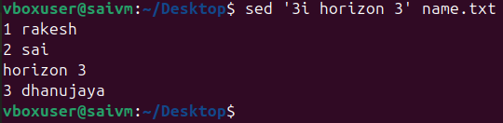

- Print only specific lines from a file
